LKS WEB TECHNOLOGIES
ADVANCED FULLSTACK SYSTEM CHALLENGE
SISTEM DIGITAL PEMBIAYAAN UMKM NASIONAL

DESKRIPSI UMUM
Pemerintah ingin membuat sistem Digital Pembiayaan UMKM Nasional untuk membantu pelaku usaha kecil mendapatkan pembiayaan secara online.

Sistem memiliki proses:
- Registrasi & login pelaku UMKM
- Verifikasi data usaha
- Pengajuan pembiayaan
- Proses approval bertingkat
- Pencairan dana
- Monitoring cicilan

sistem berbasis:
- Laravel 11.x (REST API + Sanctum + Policy + Gate)
- React 18.x / Vue 3.x (SPA)
- MySQL

ROLE & HAK AKSES (RBAC)
Terdapat 5 Role:
Role | Deskripsi
applicant | Pelaku UMKM
verifier | Petugas verifikasi data
analyst | Analis kelayakan usaha
manager | Manajer approval akhir
admin | Super admin
Gunakan:
- Middleware role-based
- Policy untuk otorisasi resource
- Token berbasis Sanctum

FLOW APPROVAL KOMPLEKS
Alur Pengajuan Pembiayaan:
- Applicant mengajukan pembiayaan
- Verifier memvalidasi dokumen
- Analyst melakukan analisis kelayakan
- Manager memberi approval final
- Sistem otomatis membuat jadwal cicilan
Jika salah satu tahap reject → kembali ke applicant dengan alasan.

PHASE 1 – REST API
- AUTHENTICATION & ROLE

Endpoint Login

POST /api/v1/auth/login

Body:
{
"email": "umkm@mail.com",
"password": "password123"
}

Response:
{
"id": 1,
"name": "Budi Santoso",
"email": "umkm@mail.com",
"role": "applicant",
"token": "1|xxxxxxx"
}

- VERIFIKASI DATA USAHA
Aplikasi harus mengisi:
- Nama usaha
- NIB
- NPWP
- Omzet per bulan
- Jumlah karyawan
- Lama usaha

Status:
- draft
- submitted
- verified
- rejected

Submit Verifikasi
POST /api/v1/business-verifications
Hanya role: applicant

Approve / Reject Verifikasi
PATCH /api/v1/business-verifications/{id}/approve
Hanya role: verifier
Jika reject:
{
"reason": "NPWP tidak valid"
}

- PENGAJUAN PEMBIAYAAN
Applicant hanya bisa mengajukan jika:
- Verifikasi usaha status = verified
- Tidak memiliki pengajuan aktif
Field:
- jumlah_pembiayaan
- tenor_bulan (6,12,24)
- tujuan_pembiayaan

Ajukan Pembiayaan
POST /api/v1/financing-applications
Validasi tambahan:
- Maksimal pembiayaan = 3x omzet bulanan
- Minimal usaha berjalan 1 tahun

- PROSES ANALISIS (ROLE: analyst)
Analyst mengisi:
- skor_kelayakan (1-100)
- rekomendasi_limit
- catatan_analisis

Status berubah:
- under_review
- recommended
- rejected_by_analyst

- APPROVAL MANAGER (FINAL)
Manager dapat:
- approve
- reject
Jika approve:
- Status → approved
- Sistem generate jadwal cicilan otomatis
- Hitung bunga flat 6% per tahun
- Generate tabel amortisasi
Jika reject:
- Status → rejected_by_manager

LOGIC PERHITUNGAN CICILAN
- Rumus:
- Total = Pokok + (Pokok × 6% × tenor/12)
- Cicilan per bulan = Total / tenor
- Buat endpoint:
- GET /api/v1/financing-applications/{id}/installments

- DASHBOARD BERDASARKAN ROLE
Applicant Dashboard
- Status verifikasi
- Status pengajuan
- Jadwal cicilan
- Total sisa tagihan
Verifier Dashboard
- List verifikasi pending
Analyst Dashboard
- List pengajuan verified
Manager Dashboard
- List recommended
Admin Dashboard
- Statistik total pengajuan
- Total dana disetujui
- Total UMKM aktif

- AUDIT TRAIL (WAJIB)
Setiap perubahan status harus disimpan di tabel:
application_logs
Field:
- application_id
- status_from
- status_to
- role
- user_id
- notes
- timestamp
Endpoint:
GET /api/v1/financing-applications/{id}/logs

- SECURITY REQUIREMENTS
WAJIB:
- Policy & Gate
- Rate limiting login
- Soft delete
- UUID primary key
- Validasi Form Request
- Response JSON standar
Format response error:

{
"success": false,
"message": "Validation error",
"errors": {}
}

FRONTEND (SPA) WAJIB:
- Role-based route protection
- Dynamic sidebar berdasarkan role
- Axios interceptor (token)
- Global error handler
- Loading state
- Pagination
- Search & filter

HALAMAN WAJIB
- Login
- Dashboard sesuai role
- Form verifikasi usaha
- List pengajuan pembiayaan
- Detail pengajuan + progress approval timeline
- Jadwal cicilan (table amortisasi)
- Audit log page

DELIVERABLE
Struktur folder:
XX_ADVANCED_LKS
├── BACKEND
├── FRONTEND
├── db-dump.sql
├── db-diagram.pdf
├── postman_collection.json

Backend:
<host>/XX_ADVANCED_LKS/BACKEND

Frontend:

<host>/XX_ADVANCED_LKS/FRONTEND

Exclude:
- vendor
- node_modules

I. DESKRIPSI SISTEM
Sistem ini digunakan untuk proses pengajuan pembiayaan UMKM dengan alur persetujuan bertingkat.
Role Sistem
- admin
- applicant (pelaku UMKM)
- verifier
- analyst
- manager

II. ALUR BISNIS LENGKAP
Registrasi & Login
- User login menggunakan email & password
- Sistem menggunakan Laravel Sanctum
- Token digunakan untuk seluruh endpoint

Verifikasi Usaha
Applicant mengisi data usaha.
Status:
- draft
- submitted
- verified
- rejected
Verifier dapat:
- approve
- reject (dengan alasan)

Pengajuan Pembiayaan
Syarat:
- Verifikasi usaha status = verified
- Tidak memiliki pengajuan aktif
Status awal:
- submitted

Analisis Kelayakan (Analyst)
Status berubah:
- under_review
- recommended
- rejected_by_analyst

Approval Manager
Manager dapat:
- approve → generate cicilan
- reject → rejected_by_manager
Jika approved:
- Status = approved
- Generate jadwal cicilan otomatis
- Generate audit log

III. ATURAN BISNIS WAJIB
- Maksimal pembiayaan = 3x omzet bulanan
- Minimal lama usaha = 1 tahun
- Bunga flat 6% per tahun
- Tenor: 6, 12, 24 bulan
- Hanya 1 pengajuan aktif per applicant
- Semua perubahan status wajib masuk audit log

IV. ERD DETAIL TABEL
Berikut adalah struktur database lengkap.
TABEL: users

Field | Type | Keterangan
id | UUID (PK) | primary key
name | varchar
email | varchar (unique)
password | varchar
role | enum | admin/applicant/verifier/analyst/manager
created_at | timestamp
updated_at | timestamp
deleted_at | timestamp | soft delete

TABEL: business_verifications
Field | Type
id | UUID (PK)
user_id | UUID (FK → users.id)
nama_usaha | varchar
nib | varchar
npwp | varchar
omzet_bulanan | bigint
jumlah_karyawan | integer
lama_usaha_tahun | integer
status | enum(draft,submitted,verified,rejected)
rejected_reason | text nullable
verified_by | UUID (FK → users.id) nullable
verified_at | timestamp nullable
created_at | timestamp
updated_at | timestamp
Relasi:
- 1 user memiliki 1 business_verification

TABEL: financing_applications
Field | Type
id | UUID (PK)
user_id | UUID (FK)
business_verification_id | UUID (FK)
jumlah_pembiayaan | bigint
tenor_bulan | integer
tujuan_pembiayaan | text
skor_kelayakan | integer nullable
rekomendasi_limit | bigint nullable
catatan_analisis | text nullable
status | enum
submitted_at | timestamp
approved_at | timestamp nullable
rejected_reason | text nullable
created_at | timestamp
updated_at | timestamp

Status enum:
- submitted
- under_review
- recommended
- rejected_by_analyst
- approved
- rejected_by_manager
Relasi:
- 1 user → banyak financing_applications
- 1 application → banyak installments
- 1 application → banyak logs

TABEL: installments
Field | Type
id | UUID (PK)
financing_application_id | UUID (FK)
installment_number | integer
jatuh_tempo | date
nominal_pokok | bigint
nominal_bunga | bigint
total_cicilan | bigint
status | enum(unpaid,paid)
paid_at | timestamp nullable
created_at | timestamp
updated_at | timestamp
TABEL: application_logs
Field | Type
id | UUID (PK)
financing_application_id | UUID (FK)
status_from | varchar
status_to | varchar
role | varchar
user_id | UUID (FK)
notes | text nullable
created_at | timestamp

TABEL: personal_access_tokens (Sanctum default)

V. RELASI ERD (DESKRIPSI VISUAL)
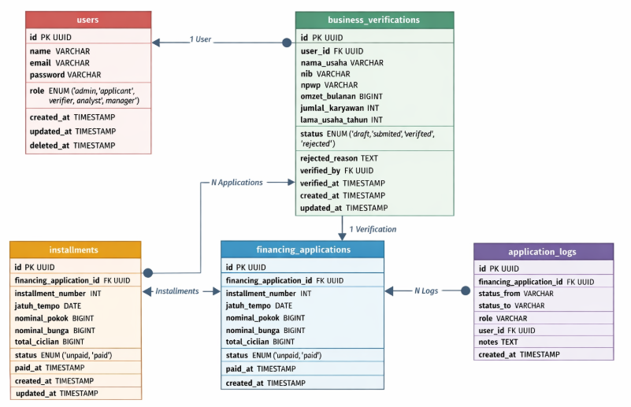

VI. CONTOH PERHITUNGAN CICILAN
Misal:
Pokok = 100.000.000
Tenor = 12 bulan
Bunga = 100jt × 6% × (12/12) = 6.000.000
Total = 106.000.000
Cicilan per bulan = 8.833.333
Sistem harus:
- Generate 12 record installments
- Nomor cicilan 1–12
- Jatuh tempo tiap 30 hari

VII. ENDPOINT WAJIB (RINGKASAN)
AUTH
- POST /auth/login
- POST /auth/logout
BUSINESS
- POST /business-verifications
- GET /business-verifications
- PATCH /business-verifications/{id}/approve
FINANCING
- POST /financing-applications
- GET /financing-applications
- PATCH /financing-applications/{id}/analyze
- PATCH /financing-applications/{id}/approve
- GET /financing-applications/{id}/installments
- GET /financing-applications/{id}/logs

VIII. FITUR WAJIB TEKNIS
- UUID primary key
- Soft delete
- Policy & Gate
- Form Request validation
- Standard JSON response
- Pagination
- Filtering by status
- Search by nama usaha

IX. KRITERIA PENILAIAN
Aspek | Bobot
Database Design | 15%
REST API | 25%
Business Logic | 20%
Security & Validation | 15%
Frontend SPA | 20%
Clean Code | 5%

